DISCOVERY OF THE EUREKA MASSIVE SULPHIDE LENS USING DOWNHOLE ELECTROMAGNETICS

Jacob Paggi and Daniel Macklin
Independence Group NL, PO Box 466, South Perth, WA 6951
Keywords Eureka, Stockman, DHTEM, volcanogenic massive sulphides

Abstract
The Eureka massive sulphide lens is the first new discovery of VMS mineralisation at the Stockman Project since 1979. The discovery was made in early 2013 through the integration of geophysical techniques, particularly down-hole electromagnetics, with a robust geological interpretation.
The lens is located approximately 350m northeast of the Currawong deposit, immediately along strike and beneath the Bigfoot lens at a depth of 360m. Though surface EM methods played key roles in the discovery of the main deposits at Currawong and Wilga, airborne and fixed-loop EM surveys failed to detect the Eureka lens due to its moderate conductance and increased depth. Interpretation of subtle DHTEM responses in two exploration drill holes was a key component of the discovery. Additional geological input, including short wavelength infrared modelling and structural reinterpretation, presented a compelling drill target, which led to the discovery of the Eureka massive sulphide lens.
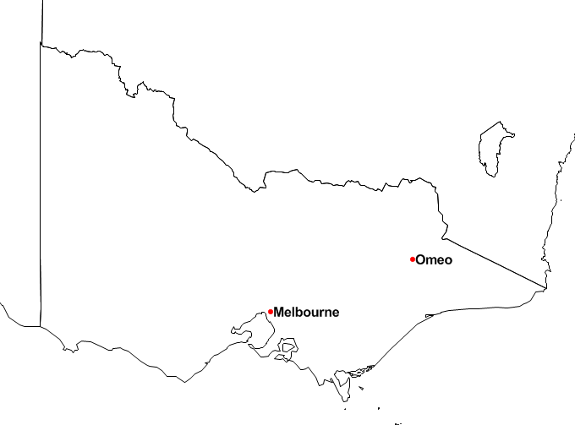
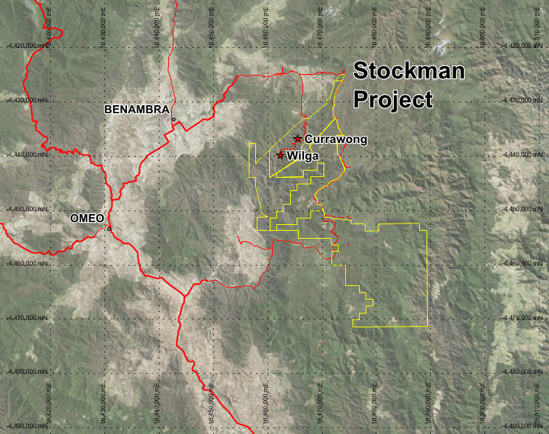

Figure 19. Location of Independence Group’s Stockman project, 18km east of Benambra, Victoria.

Introduction
The Stockman volcanogenic massive sulphide (VMS) deposits (formerly Benambra) were discovered by Western Mining Corporation (WMC) in 1978. The Eureka lens, discovered in 2013 by Independence Group NL (IGO), was the first new discovery of VMS sulphide mineralisation since 1979.
The Stockman project is located 18km east of the township of Benambra, Victoria (Figure 19). It consists of the Currawong and Wilga VMS deposits with a combined resource of 13.9 Mt @ 2.1% Cu, 4.3% Zn, 38g/t Ag and 1g/t Au (Independence Group NL, 2013).
The Eureka lens lies approximately 350m to the northeast of the Currawong deposit, at a depth of 360m. Mineralisation was discovered by integrating subtle responses observed in down-hole transient electromagnetics (DHTEM) with a robust geological interpretation. A resource has not yet been defined and the lens remains open in all directions

Geology
The Stockman VMS deposits are hosted near the top of the Limestone Creek Graben, the southernmost of the Silurian rift basins in the Lachlan Fold Belt, known to contain VMS deposits (Vandenberg et al., 1998).
Mineralisation is hosted near the top of the basin in the Gibsons Folly Formation - a narrow, northeast trending belt of siltstones/mudstones intercalated with extrusive and/or intrusive volcanic rocks, and their associated volcaniclastic units, ranging in composition from rhyolite to basalt. The rocks were emplaced in a moderate to deep subaqueous environment (Allen, 1992).
The Eureka lens is hosted on the same stratigraphic horizon as the main ore lens (M) at Currawong. As such, Eureka is interpreted to have formed contemporaneously with Currawong. The main mineralised zone is interpreted to be replacement style massive/semi-massive sulphides, with sub-conformable stringer mineralisation within sediments. A coherent and impermeable dacite porphyry overlays the sediments and is interpreted to have acted as a cap, which trapped ascending hydrothermal fluids during the mineralising event, evidenced by a strong alteration halo in the hanging wall porphyry (Macklin 2013).
The structure at Eureka is analogous to Currawong, where northwest-dipping thrust faults have resulted in multiple stacking of stratigraphy and mineralisation. Two major shear zones have been identified to date which are essentially extensions of the Currawong Shear. This forms a relatively well-constrained structural framework for the Eureka area (Macklin, 2013). It is interpreted that the Eureka lens lies in the footwall position to the Bigfoot lens, conformable to the M- and A-lenses respectively at Currawong (Figure 20).

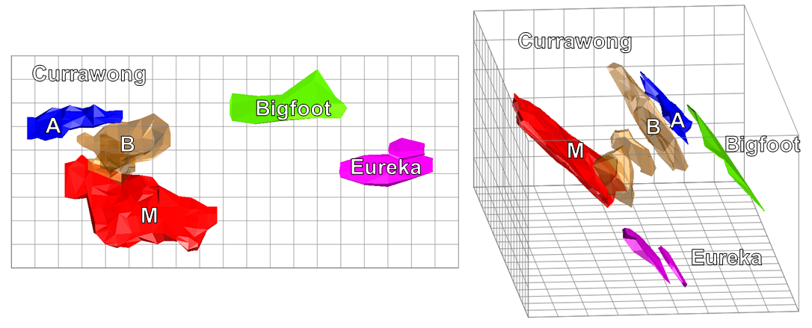

Figure 20. Plan view (left) and oblique view from 095º (right) showing the interpreted footwall position of the Eureka lens (purple) to the Bigfoot lens (green). This is conformable to the M-lens (red) and A-lens (blue) at Currawong. Additional massive sulphide stacked lenses at Currawong are shown in brown. Grid projection is Stockman Regional Grid (SRG).

Exploration History
Australian Geophysical Pty Ltd first identified the Stockman project as a potential VMS district through reconnaissance stream sediment sampling carried out in 1967. Follow up stream sampling by WMC in the early 1970’s confirmed the anomalies and reconnaissance soil sampling was used to delineate prospect areas (Chenoweth and Barr, cited in Rajagopalan and Haydon, 1999).
Prospect areas were further screened prior to drilling using frequency-domain induced polarisation surveys (Barr et al, cited in Rajagopalan and Haydon, 1999). These low-powered systems generated weak responses and were difficult to use in the steep terrain and thick vegetation. Early drilling intersected disseminated pyrite and some stringer chalcopyrite, though no significant massive sulphides were intersected.
WMC recognised that a time-domain electromagnetic survey might be more useful than IP in detecting massive sulphides (Barr et al, cited in Rajagopalan and Haydon, 1999) and in 1977-78 employed a 50m moving-loop TEM survey beginning at the Wilga prospect. The survey detected an anomalous response on the last station of the planned program, and when extended, showed a strong anomaly. This was subsequently drilled and Wilga was discovered. A 100m moving-loop survey was then conducted over the other prospects. Currawong gave the next strong response and subsequent drilling resulted in the discovery of a second VMS deposit.
The project was sold in 1986 to Macquarie Resources who entered into a joint venture with Denehurst Limited and commenced mining Wilga in 1992. Mining ceased in 1996 and the project was put on care and maintenance. In 2003, a bushfire destroyed the entire site infrastructure, including the core shed and much of the historic drill core. The Victorian government subsequently took over the responsibility of rehabilitation for the project.
Jabiru Metals Ltd won a tender for the project in 2007. Because of the lack of historic drill core, the company was required to re-drill the deposits to confirm the resources were JORC compliant. In 2008, the company flew a versatile transient electromagnetic (VTEM) survey. This failed to detect any significant anomalies indicative of massive sulphides beyond the Wilga and Currawong deposits.
Independence Group NL acquired the project through the takeover of Jabiru Metals Ltd in 2011. In 2011-12, IGO trialled multiple large, high-powered, fixed-loop TEM surveys aimed at detecting deeper mineralisation. Unfortunately, super paramagnetic effects dominated responses and no conductors indicative of massive sulphides were detected.
In 2012, a diamond drill program was designed to target relatively shallow, high-grade mineralisation at the Bigfoot prospect, approximately 200m northeast of Currawong. Ten holes were drilled into the Bigfoot horizon including two step-out holes - designed to intersect the horizon a further 200m to the northeast. Of the two holes, 12SMDD014 was extended by 100m to 450m depth, as the hanging-wall sequence was thicker than expected and therefore the prospective footwall target position deeper than anticipated.
IGO routinely surveyed all drill holes with DHTEM using a proprietary high-powered transmitter TEM system. Subtle responses were observed in the two step-out holes, indicating a conductive source, 70m west of 12SMDD014 and 100m beyond the final depth of 12SMDD015 (Figure 21). The conductor was modelled with conservative dimensions of 70m×50m and a conductance of 200S.

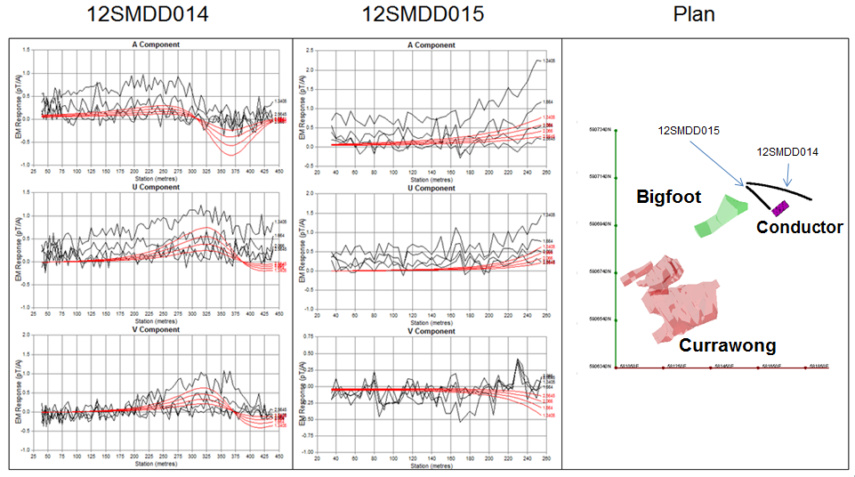

Figure 21. DHTEM responses from holes 12SMDD014 and -015 at delay times 1.34ms to 2.56ms. Observed responses are shown in black and modelled responses are in red. The location of the holes in relation to the Currawong deposit (red) and the Bigfoot lens (green) are shown in the plan view (right). The modelled conductor is shown in purple.

Follow-up geological investigation highlighted a multi-element surface soil anomaly ~400m in the up-dip projection of the modelled plate. This position had been targeted historically with shallow drilling, and low-level anomalous base metal results were never followed up. The prospective Gibsons Folly Formation was effectively open for over 300m of strike, 350m to the northeast of Currawong. Furthermore, short-wave infrared (SWIR) data, routinely collected by IGO, identified a well-constrained alteration zone that extended to the northeast, away from the Currawong and Bigfoot deposits (Macklin, 2012). Detailed geological interpretation of the stacked lenses at Currawong indicated that this alteration horizon could be related to the footwall position of the Bigfoot mineralisation.
In early 2013, IGO re-entered and extended 12SMDD015. A further 112m down hole, massive sulphides were intersected. The mineralised zone included 22.65m at 1.2% Cu, 0.7% Pb, 3.9% Zn, 43g/t Ag, and 1.3g/t Au. Subsequent drilling has defined a 200m x 90m lens of massive sulphides which remains open in all directions.

Downhole Data Acquisition and Interpretation
Prior to conducting DHTEM, responses were forward modelled to determine optimal loop positions that would achieve maximum coupling with the prospective contact. Electromagnetic Imaging Technology’s (EMIT) current filament modelling software, Maxwell, was used to display primary field vectors and a loop was positioned where these vectors were orthogonal to the contact. The extreme topography (greater than 150m relief) needs to be taken into account when planning the loop position to ensure the optimal coupling is achieved.
A surface loop with dimensions of ~600m×350m was employed for the initial DHTEM after being used for the unsuccessful FLTEM surveys. The loop consisted of a single turn of 10mm² copper wire, resulting in a resistance of 2.7 ohms.
All DHTEM data were recorded using the DigiAtlantis tri-axial fluxgate magnetometer probe and receiver system manufactured by EMIT.
IGO’s proprietary high-powered transmitter was used for all surveyed holes. The system consists of a switch, developed with Curtin University, combined with two DC power supplies powered by a 415 V three-phase generator. This allowed a peak current of 50 Amps to be transmitted at 50% duty cycle into the surface loop. The transmitter was triggered by a DigiAtlantis controller at a base frequency of 2.08 Hz.
DHTEM data were modelled using Maxwell, fitting model responses to the observed latest time channels where signal amplitudes were above ~0.1pT/A. The resultant conductor was modelled with conservative dimensions of 70m×50m and the subsequent drill hole intercepted sulphides at the modelled position.
DHTEM on the extended discovery hole 12SMDD015 has shown that the modelled conductor represents the main Eureka lens, with the upper Eureka hanging wall lens modelled as a separate 30m×20m plate.

Conclusions
The Eureka massive sulphide lens is the first new discovery of VMS mineralisation at the Stockman Project since 1979. Surface EM methods failed to detect the mineralisation due to its significant depth and moderate conductivity contrast with the host rocks. Identifying subtle responses in DHTEM data, along with the integration of SWIR and a robust geological model, were keys to the discovery. Due to the highly variable terrain, careful planning of transmitter loop positions was an imperative prerequisite in targeting the prospective, stratigraphic horizon that led to the discovery.

Acknowledgements
The authors would like to thank Independence Group NL for permission to publish this paper. Thanks also go to all the staff at the Stockman project for acquiring the data in a challenging environment.

References
Allen, R.L., 1992, Reconstruction of the tectonic, volcanic, and sedimentary setting of strongly deformed Zn-Cu massive sulphide deposits at Benambra, Victoria: Economic Geology, 87, 825-854.
Independence Group NL, 2013, Mineral resources and ore reserve estimates as at June 2013, <http://www.igo.com.au/IRM/Company/ShowPage.aspx/PDFs/2589-68037075/MineralResourcesand OreReservesat30June2013>
Macklin, D., 2012, Deepfoot drill proposal: Independence Group NL (unpubl.)
Macklin, D., 2013, 2013 Phase 1 Eureka (Deepfoot) diamond drilling program review: Independence Group NL (unpubl.)
Rajagopalan, S., and Haydon, S.J., 1999, The Benambra volcanic hosted massive sulphide deposits. In A.J. Willocks, S.J. Haydon, M.W. Asten, and D.H. Moore (eds) Geophysical signatures of base metal deposits in Victoria: Geological Survey of Victoria Report 119 and Australian Society of Exploration Geophysicists, Special Publication, 11, 23-47.
Vandenberg, A.H.M., Hendrickx, M.A., Willman, C.E., Magart, A.P.M, Simons, B.A., and Ryan, S.M., 1998, The geology and prospectivity of the Benambra 1:100 000 map area, eastern Victoria: Geological Survey of Victoria Report 114.

